Lab: DOM Manipulations
Problems for in-class lab for the "JavaScript Advanced” course @ SoftUni". Submit your solutions in the SoftUni judge system at https://judge.softuni.bg/Contests/1549/Lab-DOM-Manipulation.
- List of Items
Write a function that reads the text inside an input field and appends the specified text to a list inside an HTML page.
Submit only the addItem() function in judge.

Input/Output
There will be no input/output, your program should instead modify the DOM of the given HTML document.

Examples
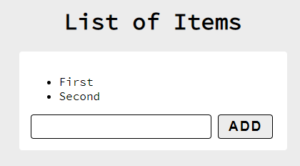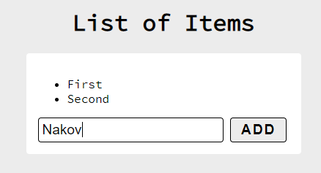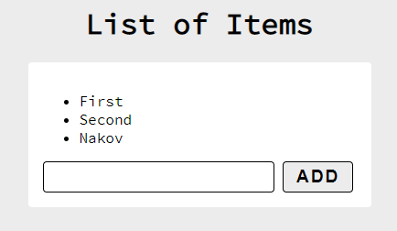
- Add / Delete
Extend the previous problem to display a [Delete] link after each list item. Clicking it should delete the item with no confirmation.
Submit only the addItem() function in judge.

Input/Output
There will be no input/output, your program should instead modify the DOM of the given HTML document.

Examples
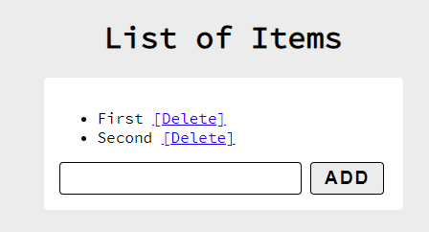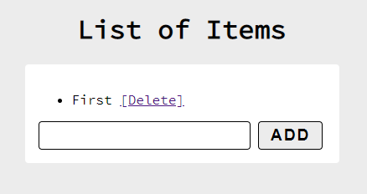
- Delete from Table
Write a program that takes an e-mail from an input field and deletes the matching row from a table. If no entry is found, an error should be displayed in a <div> with ID "results". The error should be "Not found." Submit only the deleteByEmail() function in judge.

Input/Output
There will be no input/output, your program should instead modify the DOM of the given HTML document.
Examples
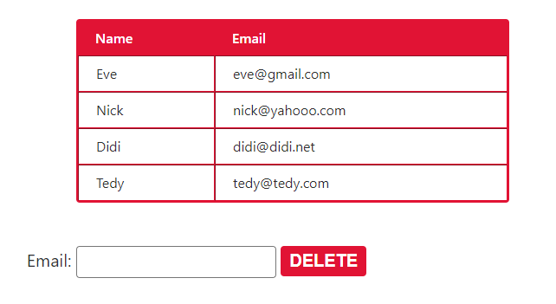
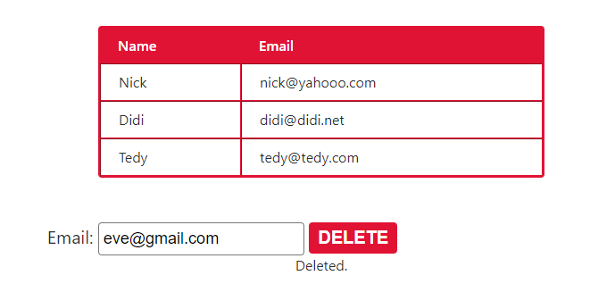
- Stopwatch
Write a timer that counts minutes and seconds. The user should be able to control it with buttons. Clicking [Start] starts the counter. Clicking [Stop] resets the timer back to zero. Only one of the buttons should be enabled at a time (you cannot stop the timer, if it is not running).
Submit only the stopwatch() function in judge.

Input/Output
There will be no input/output, your program should instead modify the DOM of the given HTML document.

Examples
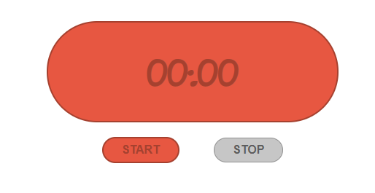
- Mouse Gradient
Write a program that detects and displays how far along a gradient the user has moved their mouse. The result should be rounded down and displayed as a percentage inside the <div> with ID "result".
Submit only the attachGradientEvents() function in judge.

Input/Output
There will be no input/output, your program should instead modify the DOM of the given HTML document.

Examples
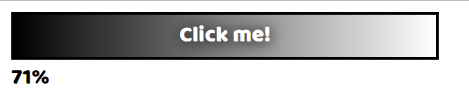
- Highlight Active
Write a function that highlights the currently active section of a document. There will be multiple divs with input fields inside them. Set the class of the div that contains the currently focused input field to "focus". When focus is lost (blurred), remove the class from the element.
Submit only the focus() function in judge.

Input/Output
There will be no input/output, your program should instead modify the DOM of the given HTML document.

Example
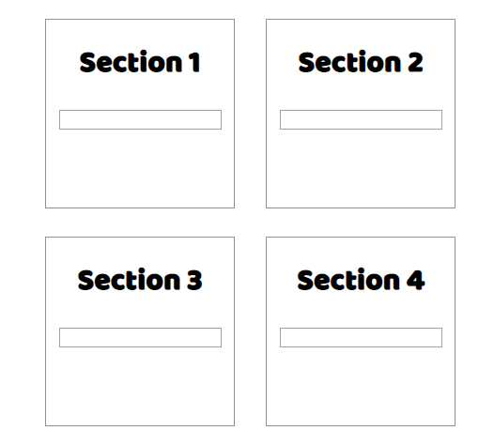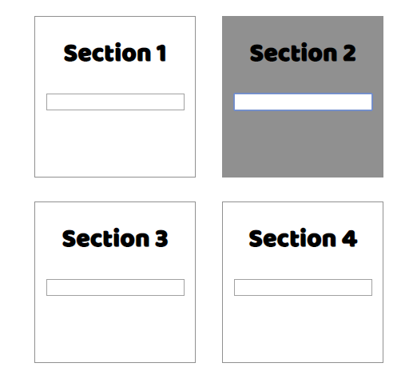
- Dynamic Validation
Write a function that dynamically validates an email input field when it is changed. If the input is invalid, apply the style "error". Do not validate on every keystroke, as it is annoying for the user, consider only change events.
A valid email is considered to be in the format: <name>@<domain>.<extension>
Only lowercase Latin characters are allowed for any of the parts of the email. If the input is valid, clear the style. Submit only the validate() function in judge.

Input/Output
There will be no input/output, your program should instead modify the DOM of the given HTML document.

Example
